Student Name: __________________
Class and Section __________________
Total Points (20 pts) __________________
Due: December 7, 2009 before the class

Project: N-Sided Regular Polygon

CSCI 1302 Advanced Programming Principles
Armstrong Atlantic State University

Problem Description:
Write a program that displays a regular polygon and uses two buttons named +1 and -1 to increase or decrease the size of the polygon, as shown in the following figure.

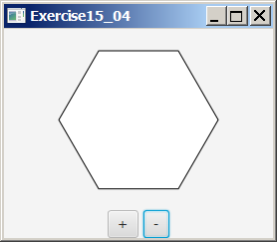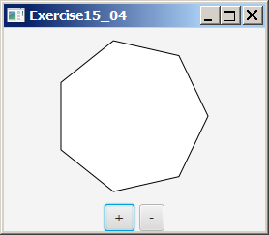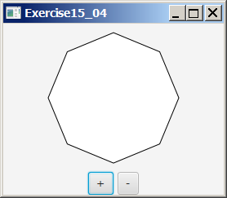

Your Task:
- Create the RegularPolygonPane class for displaying an n-sided regular polygon. n is a data field in RegularPolygonPane.
- Write the code to handle the action events from the buttons to change the number of the sides in a RegularPolygonPane object and redisplay it.

Submit the following items:

1. Compile and Submit to LiveLab as Exercise15_04Extra (you must submit the program regardless whether it complete or incomplete, correct or incorrect)

2. Fill in self-evaluation:

- Can your program create the UI? _______________
- Can your program display one polygon correctly? _______________
- Can your program display n-side polygon correctly? _______________
- Can your program handle action event from the buttons? _______________
- Can your program redisplay the polygon when the user clicks the buttons?_______________
- Can your program resize the polygon when the user resizes the frame?

Solution Code:

import javafx.application.Application;
import javafx.collections.ObservableList;
import javafx.geometry.Pos;
import javafx.scene.Scene;
import javafx.scene.layout.*;
import javafx.scene.paint.Color;
import javafx.scene.shape.*;
import javafx.scene.control.*;
import javafx.stage.Stage;

public class Exercise15_04Extra extends Application {
@Override // Override the start method in the Application class
public void start(Stage primaryStage) {
double paneWidth = 270;
double paneHeight = 210;

BorderPane borderPane = new BorderPane();
RegularPolygonPane regularPolygonPane = new RegularPolygonPane(6);
borderPane.setCenter(regularPolygonPane);

HBox hBox = new HBox(5);
Button btIncrease = new Button("+");
Button btDecrease = new Button("-");
hBox.getChildren().addAll(btIncrease, btDecrease);
hBox.setAlignment(Pos.CENTER);

borderPane.setBottom(hBox);

// Create a scene and place it in the stage
Scene scene = new Scene(borderPane, paneWidth, paneHeight);
primaryStage.setTitle("Exercise15_04"); // Set the stage title
primaryStage.setScene(scene); // Place the scene in the stage
primaryStage.show(); // Display the stage

btIncrease.setOnAction(e -> regularPolygonPane.increase());
btDecrease.setOnAction(e -> regularPolygonPane.decrease());
}

/**
* The main method is only needed for the IDE with limited
* JavaFX support. Not needed for running from the command line.
*/
public static void main(String[] args) {
launch(args);
}

class RegularPolygonPane extends StackPane {
private Polygon polygon = new Polygon();
private int numberOfSides = 6;

public RegularPolygonPane(int numberOfSides) {
this.numberOfSides = numberOfSides;
this.getChildren().add(polygon);
polygon.setFill(Color.WHITE);
polygon.setStroke(Color.BLACK);
paint();
}

private void paint() {
ObservableList<Double> list = polygon.getPoints();
list.clear();

final double WIDTH = 200, HEIGHT = 200;
double centerX = WIDTH / 2, centerY = HEIGHT / 2;
double radius = Math.min(WIDTH, HEIGHT) * 0.4;

// Add points to the polygon list
for (int i = 0; i < numberOfSides; i++) {
list.add(centerX + radius * Math.cos(2 * i * Math.PI / numberOfSides));
list.add(centerY - radius * Math.sin(2 * i * Math.PI / numberOfSides));
}
}

public void increase() {
numberOfSides++;
paint();
}

public void decrease() {
numberOfSides--;
paint();
}
}
}

